Build a Simple Coax Shield “Sniffer” Probe

A tool every-ham-should-have, an easy-to-build digital probe for detecting unwanted RF current on coax and stray RF in the shack. Also, an eye-opening look at baluns

By John Portune W6NBC and Jim Bailey W6OEK

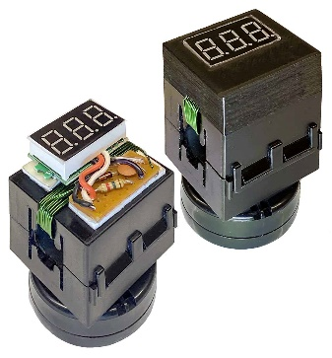

Over the years, ways to detect unwanted RF on the outside of the shield of coax have appeared often in ham literature (see references). In, co-author W6OEK’s version, Figure 1, Jim adds an inexpensive quick and easy 3-digit digital voltmeter and an optional 3D printed dress-up cover to a common ferrite clamp-on choke with an added RF pickup coil.

Figure : RF Coax RF Shield Current Probe

But more important than just a useful addition to your toolkit, is the bigger picture that this handy little “snooper” brought home to Jim and me about baluns and coax shield current. Stay tuned for the revealing story later in this article.

Bill of Materials

|  |  |  |
| --- | --- | --- |
| 1 | Snap-on mix 43 Ferrite choke for RG-8, RG-213 size coax. (0.405 in.) | e.g. Fair-Rite 0443164151 snap-in, Palomar Engineers FSB43-1/2, ID=1/2" or similar |
| 10 turns | Insulated magnet wire,  AWG 24 (or smaller) | Electronic parts supplier |
| 1 | 3-digit digital voltmeter, 3-wire 100V version (see text) | Amazon, EBay, mpja.com, Walmart, surplus electronics dealers |
| 1 | 1N34 diode | Electronic parts supplier |
| 1 | 0.001 μfd. 100V disc ceramic capacitor | Electronic parts supplier |
| 1 | 1k ¼ W carbon resistor | Electronic parts supplier |
| ---- | 100 mil linear copper strip perfboard | Electronic parts supplier |
| 1 | 2 cell (6V) 2032 coin cell holder with cells and switch | https://www.amazon.com/dp/B092VFFCR8?psc=1&ref=ppx_yo2ov_dt_b_product_detailsAmazon, EBay |
| ---- | 3M VHB Double Sided Heavy Duty Outdoor Mounting Tape or sticky squares | Local hardware store, internet |
| 1 | 3D printed probe cover | .stl 3D printer file: w6nbcmail@gmail.com |

Construction

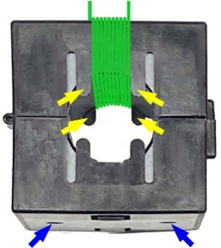

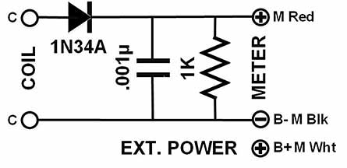The ferrite choke for the RG-8 size choke” was purchased directly from fair-rite.com, retail on-line sales. Similar snap-on chokes are also suitable. The RF pick-up coil is ten turns of 24 AWG or smaller, insulated magnet wire wound on the side opposite the mounting holes in the back (blue arrows). If the small tabs (yellow arrows) prevent the wires from lying flat, snip off just the tips.

Figure 3: Schematic

ADD

Figure 2: Fair-Rite snap-on choke with RF pick-up coil

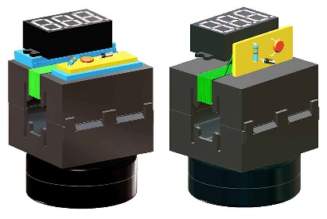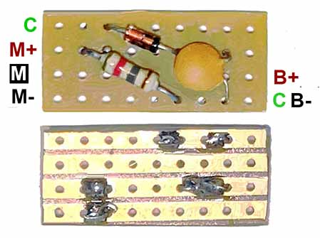Figure 4 is a small perfboard for mounting the components. If you don’t use the 3D printed cover, attach the meter and the perfboard with double-sided sticky tape, Figure 5. With the cover, the display and the perfboard are held by bosses inside the cover.

Figure 5: Component placement with 3D printed cover (right) and without (left)

Figure 4: Perfboard with wire connections

The 3-wire 0-100 Volt digital meter needs a source of power. We used a small battery holder, with an on-off switch, that holds two 2032 coin cells, providing 6 volts. We fastened the holder to the bottom of the ferrite case with double sided tape and routed the wires up the back side and under the meter to connect to the perfboard.

Using the Probe

The probe is just a guide for determining the presence of RF shield current on the coaxial feed line and measuring the reduction of this shield current as chokes are added.

If the probe indicates that there is RF on the coax shield, establish a reference point by adjusting the output of your transmitter in the CW mode. Set the transmitter output for a reading of 35 to 40 Volts on the probe. Next, add ferrite chokes to the transmission line and observe the reduction of the voltage on the meter, until adding more chokes produces little additional change.

NOTE: Test more than just coax. The probe functions well on all lines, e.g. (1) DC power cables, (2) AC cords and house wiring, (3) audio cables, (4) control lines (5) computer cables, and even (6) RF ground lines and straps. You may be surprised where your transmitter power is going, instead of to your antenna(s).

Our Story

The big lesson that this little probe taught us, began when Jim quickly put up an OCF 80-meter dipole and fed it with coax without a balun. Then, as common balun wisdom predicts, the probe detected RF current on the shield of his coax. As “a quick fix,” he put ferrite snap-on chokes on all his audio cables with ~~no~~ little improvement.

He then “bit the bullet,” lowered his dipole and installed a 1:1 current choke balun at the antenna, seven mix 43 ferrite snap-on chokes. As most hams would figure, “Surely that would do the trick,” or so he thought. His “unbalanced” coax would now be “correctly” connected to his “balanced” antenna.

But again, not so. Measured with the little probe at the shack, there still was major common-mode current on the shield and stray RF in the shack. What was happening? Why hadn’t the BALUN, according to common wisdom, put where it is “supposed” to be put, fixed the problem? Fortunately, there is an answer, which many may find eye-opening. It was to Jim and to me.

The “Joy” of Coax

WWII had a big impact on both ham radio and commercial radio. One in particular was a shift from unshielded “balanced” open-wire feed line to shielded “unbalanced” coax. Interference was greatly reduced. It was little wonder that all radio services quickly adopted coax. And along with coax came the BALUN.

As a historical note, the first reference in radio literature to a balun appears to be for the first TV broadcast antenna on the Empire State Building in 1936.

The “Eye-Opener”

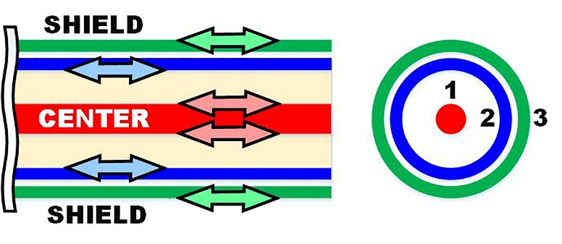The new view of baluns that this little probe helped Jim and me see begins in Figure 6, two cross sections of coax, a side view and an end view.

What’s surprising here, is that coax is shown with three conductors. You might think, just looking at it, that coax has only two conductors – a center conductor and a shield. But that’s not how the current “sees” it. Two conductors are only how direct current, and to a small degree low frequency alternating current, sees coax. To radio frequency (RF) current, coax effectively has THREE conductors: (1) the surface of the center conductor, (2) the inside surface of the shield, and (3) the outside surface of the shield.

Figure 6: Cross sections of coax

The reason is simple – SKIN EFFECT.As many hams know, alternating current, particularly radio frequency current, runs only on the surface and at the edges of a conductor. The magnetic field inside a conductor forces AC and RF current outward, away from the center and onto a very thin “skin,” at most only a few thousandths of an inch thick.

The shield, however, being a cylinder, has two surfaces. The current is pushed outward in two directions and two skins are created. And, what’s more, those two skins are separate. Current can flow on both independently and in either direction simultaneously. Therefore, for RF coax has three conductors, again: **(1) the surface of the center conductor, (2) the surface of the inside of the shield, and (3) the surface of the outside of the shield.**

But wait. Even more important in the saga of baluns and shield (common-mode) current are the red circles seen in Figure 7. Skin effect does something else very important. *It ALSO short circuits the two skins together*. And this is extremely important. For it is the way that RF current most commonly makes its way onto the outside of the shield of the coax. It is also the most important point of this article. Capture it!

To grasp this vital point, note Figure 7. It shows an antenna connected to the end of coax to illustrate how RF gets onto the outside of the shield at an antenna without a balun.

Figure 7: Coax connected to an antenna without a balun.

When antenna current, completing the circuit back to the transmitter, encounters the short circuit at the red circles, it divides. Part of the current takes the inside path *–*  the correct path – and part of it takes the outside path – the NO-NO path, the “trouble” path.

To better grasp the implicaton, consider Figure 8. It is a balanced antenna, fed with a open-wire balanced feedline. Ask yourself, what consequences would you expect if you were to theoretically connect a third (black) wire of random length to one side of the feedpoint of this properly balanced antenna and feedline?

Figure 8: A balanced antenna and feedline with an added 3rd. wire

The answer, of course, would depend on the length of the third wire, in what direction it leaves the antenna, whether it was straight or bent and to what it became connected to at the other end if anything. But regardless, it is clear it that would very likely create problems for the antenna such as: (1) the SWR might change, (2) the radiation pattern might change or (3) the resonant frequency might shift. Also, it might cause interference to or pick up interference from other nearby radio systems.

It is vital to realize that this theoretical third wire is entirely analogous to what happens when skin effect separates the shield of coax into two separate and independent conductors and short circuits the two conductors together WHEREVER coax ends. For it indeed is what makes coax an unbalanced” transmission line. Now Notice Figure 9.

Enter the Humble Balun.

For while it is true that a balun does convert unbalanced coax to balanced transmission line, it is far more meaningful to think of it as a device that inserts a “blockage” or a “choke” into the third conductor of coax. That rather is the PRIMARY FUNCTION of a balun.

Figure 9: The primary function of a balun is to block coax shield current.

For reference, the commonly accepted minimum choking value is an AC resistance (reactance XL) of 200 Ω – four times the 50 Ω system impedance, as shown in Figure 9.

All baluns, whether they are wound on ferrite rods or toroids, are made from bundles or coils of coax, or are constructed from phased coax stubs, choking off of outside shield current is always the PRIMARY function. Nor does itmatter if they are 1:1, 4:1, 9:1, etc., If it were up to me I would change the name “balun” to “shield current choke.” For it identifies what baluns do and as we shall now see, it does not limit the use of the device. to just at the antenna.

The Bigger Picture

So, as in the old days of radio, “Don’t touch that dial;” there’s more to this story. We have still not solved the mystery of why, after installing a balun – oh pardon me, a coax shield current choke – at the antenna, that the probe was still detecting stray RF in the shack. This is the exciting part of our adventure, boys and girls. You may be in for a surprise.

To see it, turn your attention now to the other end of Jim’s coax, Figure 10. Surprise, surprise there are red circles there too.

The transistor (or vacuum tube) in yourrig is a balanced source of RF energy. And when, just like at the antenna, the signals from it encounter the short circuit at the end of the coax to which they are connected, they too will divide and get onto the shield.

Figure 10: The same red circles exist at the shack end of the coax.

AXIOM: Every place that coax ends in a radio system, where there is a balanced source of RF energy, because of the short circuit at the end of coax, it is possible for RF to get onto the outside of the coax.

The only thing that can prevent it, other than adding shield chokes (a balun) at the transmitter end of the coax, is if the coax is **100%** grounded. Then any outside shield current will be shunted to ground. But as any competent RF engineer and many hams know, there is no such thing as a good RF ground. The very best array of ground rods, copper straps and radials that one can muster is only a “fair” RF ground. There will never not be a significant path for RF to get onto the outside of the shield at the shack end of coax.

Therefore, despite common wisdom about where baluns “should” be used, the little probe dramatically showed Jim and me that several coax shield current chokes ( balun) at his shack were needed to clean up the stray RF in his station, even with a proper balun at the antenna.

NEVER FORGET, baluns (coax shield current chokes) aren’t JUST for antennas. That’s why I don’t think of them as baluns but as coax shield current chokes. And I now have 1:1 shield current chokes at both ends of all my coaxes and at other places coax ends, even where I already have an existing 4:1 or other multi-impedance balun. There is no harm in having more than one balun on a coax.

In later episodes of our “balun” adventure, we found that the outside of the shield is fair game for “attack” from other sources,” even in Jim’s case from a VHF antenna coax passing nearby his 80-meter coax. Another was the angle that the coax exited his 80-meter dipole; it wasn’t 90 degrees. Direct radiation from one side of the dipole was inducing current onto the shield.

That third coax wire is nasty. But it was our thinking that “all that one needs to do,” is to balance the feedline with one balun at the antenna that prevented us from seeing the big picture. Unbalance to balanced is not the big issue with baluns (shield current chokes), choking is.

Build one of these handy little probes, test ALL your cables, even your grounds and your house wiring and choke, choke, choke! You may be surprised. You will reap the benefit of more than one “shield current choke” (baluns) throughout your system, not just at your antennas. Think, “shield current chokes.”

SOME REFERENCES

https://sz1a.org/en/featured-articles/how-to-easily-measure-unwanted-rf/#:~:text=When%20transmitting%2C%20the%20current%20flowing%20on%20the%20outside,and%20displayed%20as%20an%20indication%20on%20the%20instrument.

Owen Duffy, An Approach to the Measurement of Common Mode Current

https://owenduffy.net/module/icm/#:~:text=An%20approach%20to%20measurement%20Common%20mode%20current%20can,half%20wave%20detector%20driving%20a%20high%20impedance%20voltmeter.

https://ham.stackexchange.com/questions/1271/how-to-detect-common-mode-currents-or-rf-in-the-shack